Mask aligner
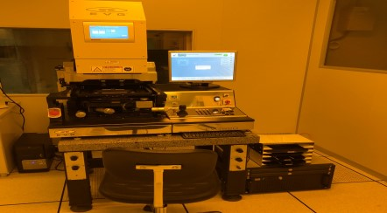

Mask size (diameter):
five inches, four inches
Sample size (diameter):
two inches, four inches, slice (size above 1cm square and below 2 inches in diameter)

We provide S1813 photoresist and standard Micrometer Lithography Process

1,000 NT/Hr

